PREREQUISITES

IBM Cloud services

|  |  |
| --- | --- |
| DATE | 10/11/2022 |
| PROJECT NAME | Real-Time River Water Quality Monitoring and  Control System |
| MARKS | 4 marks |

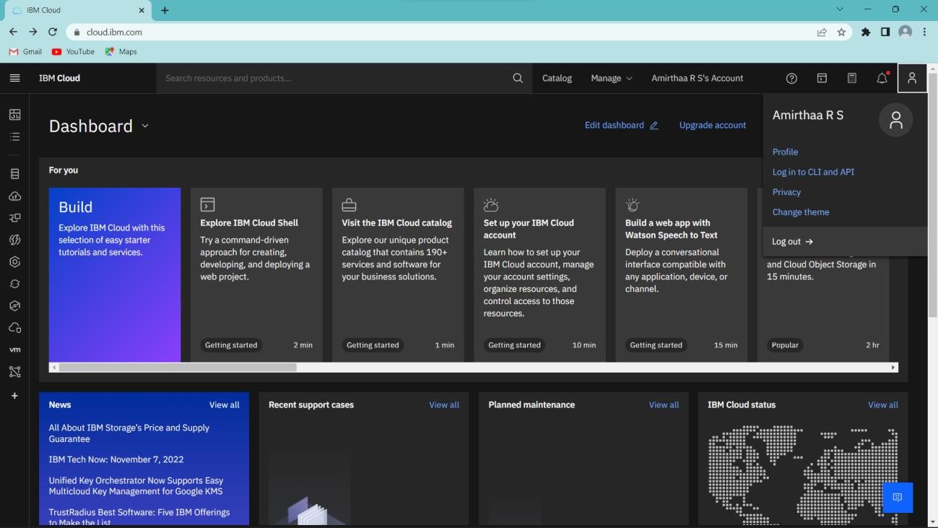



Resource list

"’•'°• °’°°



